Japneet Kaur (Group-5)

Problem Statement: There can be multiple customers, who can place multiple orders on the site. Now a sales person can handle these orders will distribute into multiple sales persons (One order will be assign to one salesperson only). So a sales person can have multiple orders of multiple customers
- Create Database++
create database japdb;
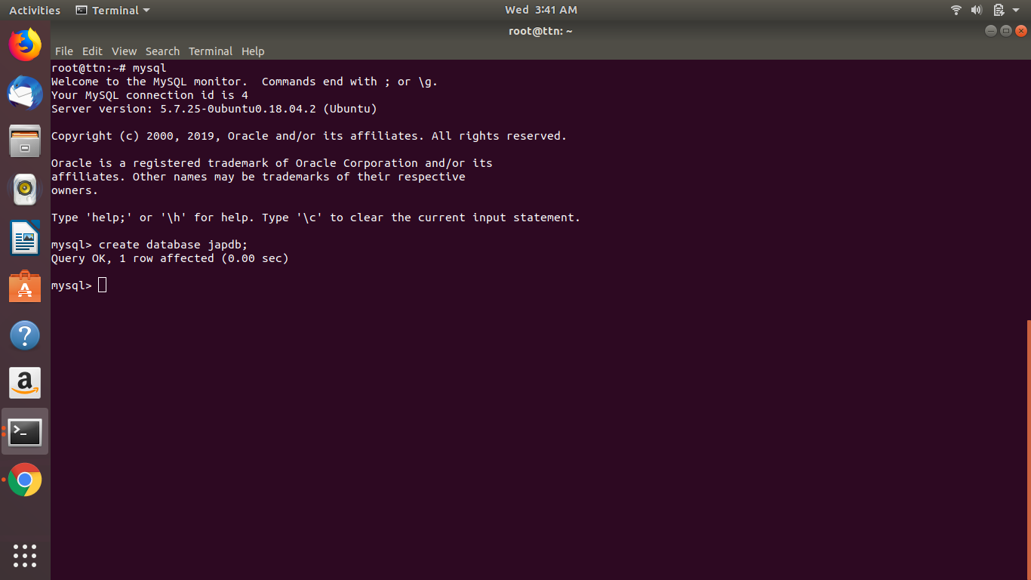

- Design Schema
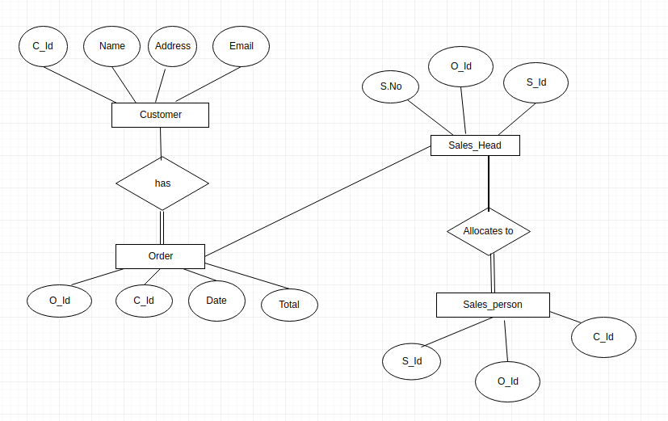
- Create tables
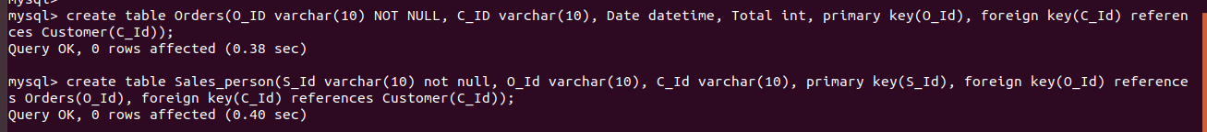

- Insert sample data
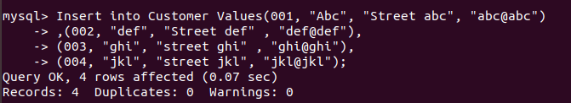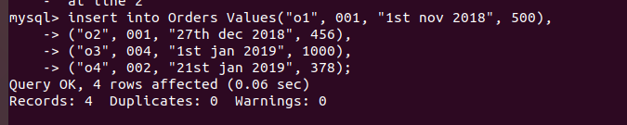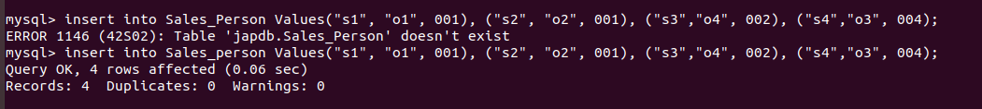
- Find the sales person have multiple orders.
- Find the all sales person details along with order details
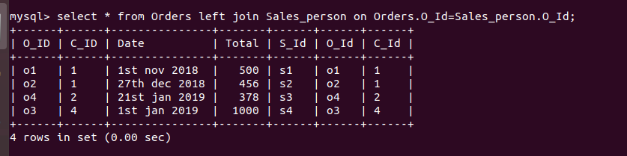
- Create index

- How to show index on a table
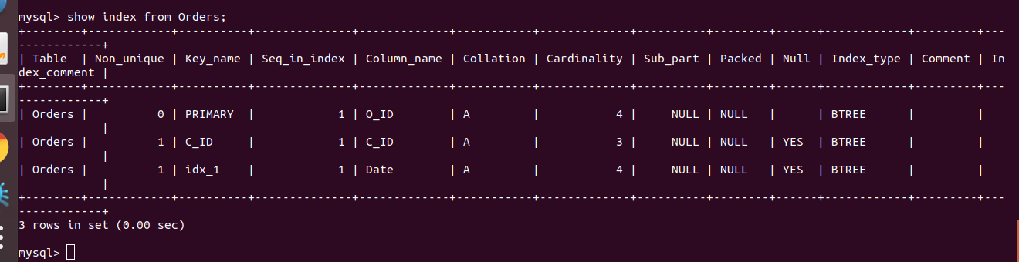
- Find the order number, sale person name, along with the customer to whom that order belongs to
